**Votely**

A Secure, Transparent, and Decentralized Voting System

# Team 3

**Abinesh Haridoss** (MS Computer Science), **Linh Doan** (MS in Information Systems), **Renugopal Sivaprakasam** (MS Computer Science), **Yi-Hsun Hsu** (MBA in Business Analytics)

GradinnoHack Table Choices

* **Technology**: Cybersecurity
* **Impact Area**: Government Transparency
* **User Group**: Any organization or Government
* **Github**: <https://github.com/regostar/blockchain_voter2>

# Problem Statement

Voting is the foundation of decision-making in any organization - whether it's a government, a university, a company, or a community group. Yet, many existing voting systems struggle with common issues: lack of transparency, difficulty verifying results, limited accessibility, and challenges in scaling securely.

How can we make the way we vote more secure, fair, transparent, and accessible?

Proposed Solution

That’s why we built **Votely** - to redefine the future of voting. Votely is a secure, blockchain-based voting system designed to restore trust, prevent tampering, and make voting more accessible. Whether for national elections or internal organizational polls, **Votely** ensures every vote counts and can be verified.

Implementation

* **Blockchain Platform**: Solidity, Ganache, MetaMask, Web3.js
* **Frontend**: React, Ethers.js
* **Backend**: TypeScript, NodeJS, Express.js,
* **Data Storage**: PostgreSQL
* **Authentication & Security**: JWT, bcrypt, MetaMask
* **MVP Scope**:
  + User registration & eligibility validation (simulated)
  + Vote casting via smart contract
  + Vote encryption
  + Vote tally and result display
  + Blockchain storage system

Results & Demo

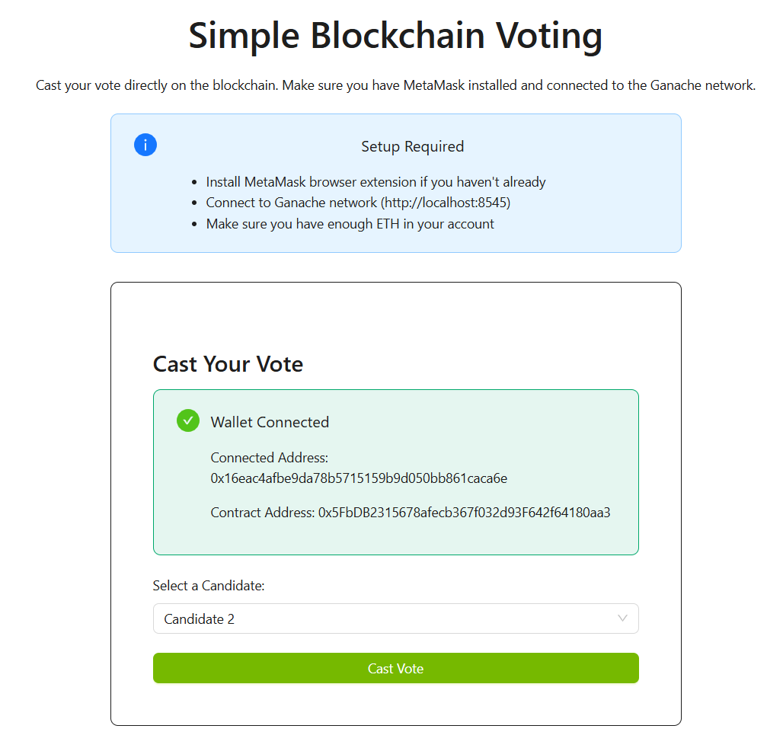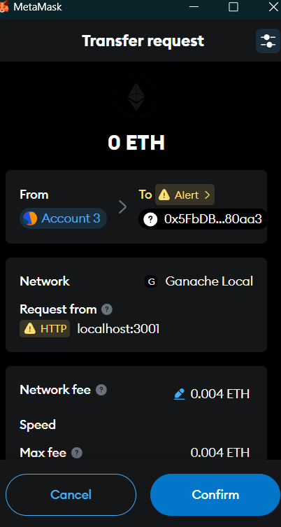

Impacts

**Societal Benefits**

* **Prevents possible fraud** and tampering through blockchain’s transparency.
* **Builds public trust** with verifiable, tamper-proof records.
* **Improves accessibility** for all ages with **remote** and **in-person** digital voting.
* Provides **instant, transparent results** via public blockchain ledger.

**Unique Value Propositions**

* **Transparency** and **real-time** results for the entire user base.
* **Secure and confidential** election
* **High accessibility and availability**, allowing anyone to vote or monitor results from anywhere
* **Consistency** with government systems or organizations by integrating SSN-based or SSO-based synchronization for eligibility validation

**Next Steps**:

* By integrating **Agentic AI Flow** for anomaly detection, the system can automatically identify unusual voting patterns.
* Partner with local civic bodies for pilot testing
* Optimize scalability for national-level elections
* Explore **Layer 2 solutions** (e.g., Polygon) to reduce gas fees

**Scalability**:  
**Votely** is more than just a voting tool **- it’s a scalable, modular platform designed to support a wide range of voting campaigns across any organization.** From local communities to national elections, ElectraTrust can adapt to various use cases. Powered by blockchain technology, it ensures cost-effective, secure participation for millions of voters.